**OPIM 5641: Homework III**

**Optimization: Using RiskSolver**

1. Solve the base case model. How many stocks were selected? How many constraints are binding? Can you predict how many stocks would be selected (and which ones) when there are no requirements? Why?

**Answer:**

Number of Stocks selected is 4.

2 constraints – Decision variables (stocks invested), Tech and Non-Tech are binding.

Base Case model:

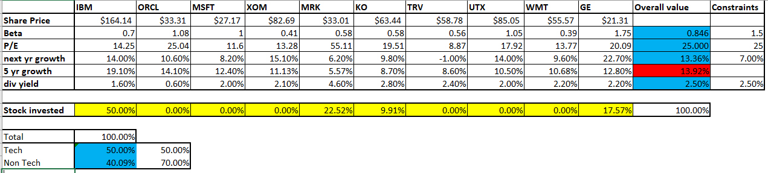

Only IBM will be selected with no requirements or constraints because this stock has the highest 5-year growth.

1. Perform a sensitivity analysis of the objective function with respect to risk. Set the required **dividend yield** to zero. Then vary the **portfolio beta** from 0.4 to 1.5. Make a chart with risk on the horizontal axis and 5-year growth on the vertical axis.   
   Which stocks are selected:
   1. In a low-risk portfolio (beta=0.4)?
   2. In a medium-risk portfolio (beta=1.0)?
   3. In a high-risk portfolio (beta=1.5)?

Answer:

* 1. Stock Selected: IBM, WMT

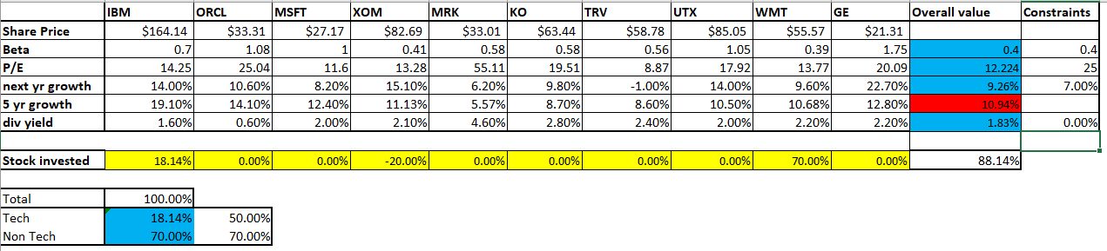

* 1. Stock Selected: IBM, XOM, GE

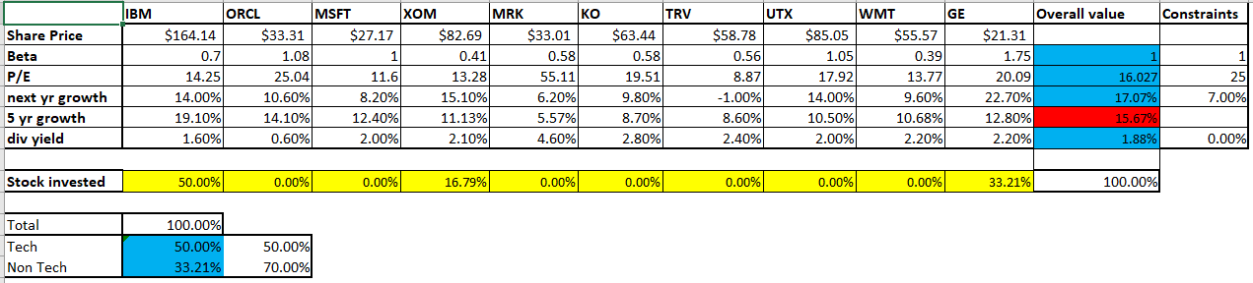

* 1. Stock Selected: IBM, ORCL, GE

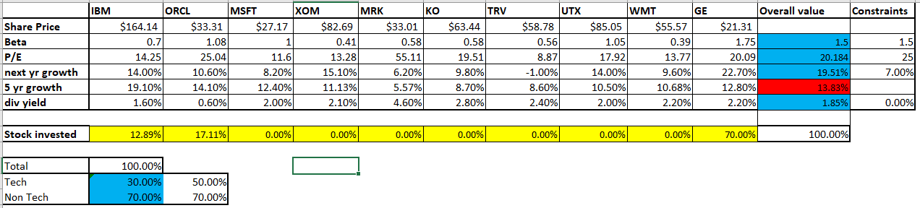

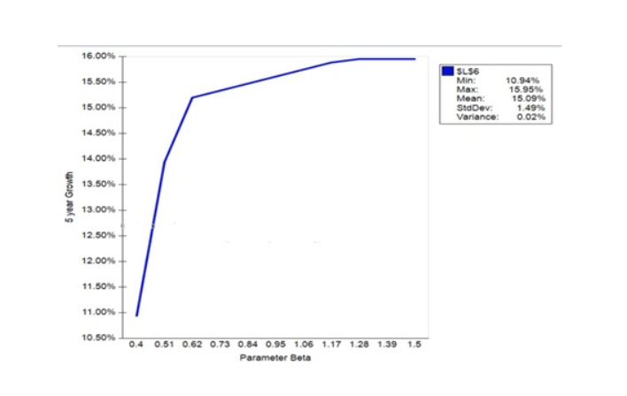

Low Value: 10.94%

High Value: 15.95 %

1. Suppose Merck (MRK) discovers a blockbuster drug: a cure for cancer. As a result, its 5-year growth estimate will increase and hence its portfolio allocation may increase. Since Merck’s P/E will also decrease, we make the **portfolio P/E** constraint ineffective by setting its right hand side to 125. Present a chart showing the percent invested in MRK as a function of its expected 5 year growth. Vary the 5-year growth from its current value (6.35%) to 40% and show how the **optimal percent** invested in MRK changes.

